2200032991
WEEK-5 ADDITIONAL HANDS-ON
Create Eureka Discovery Server and register microservices
Here from the question given we need to generate total 5 zip files from the below ink
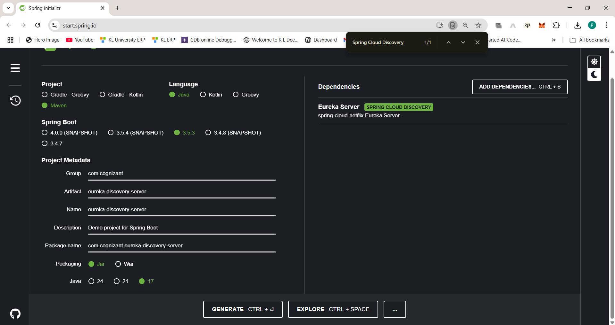
Like this total 4 files
Names are different but the dependencies should be EUREKA SERVER
Make sure that it is in maven to get your pom.xml file
Change your artificate names
- Account
- Api-gateway
- Eureka-discovery-server
- Greet-service
- Loan
Download and extract them
Keep them in a file as shown
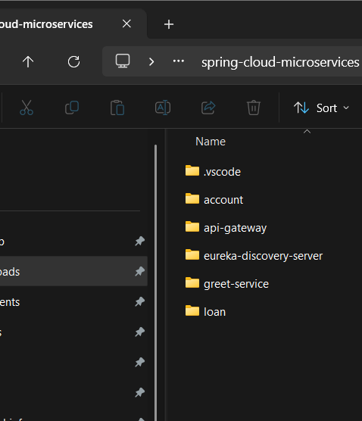

Now go to the vs code and open your files
open all and run them in the terminal With respect to their paths
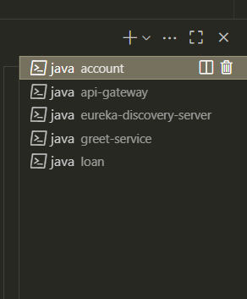
Change the application.properties and see the required info is there
Add the controller file

Eureka-discovery-server
http://localhost:8761

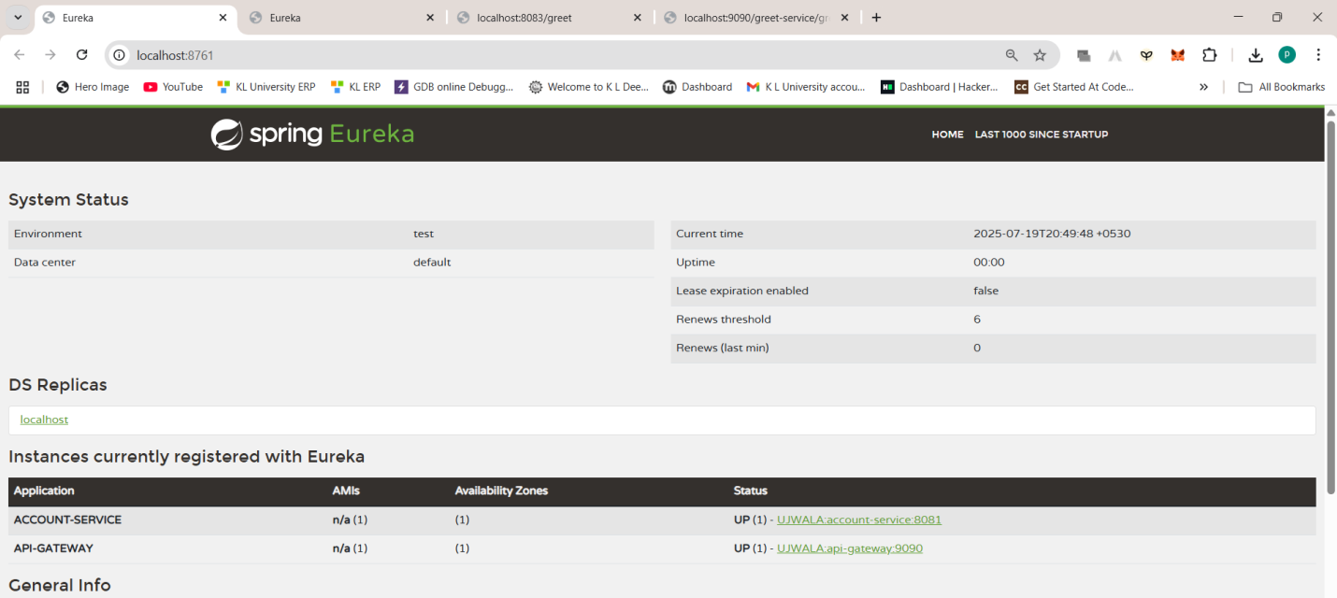
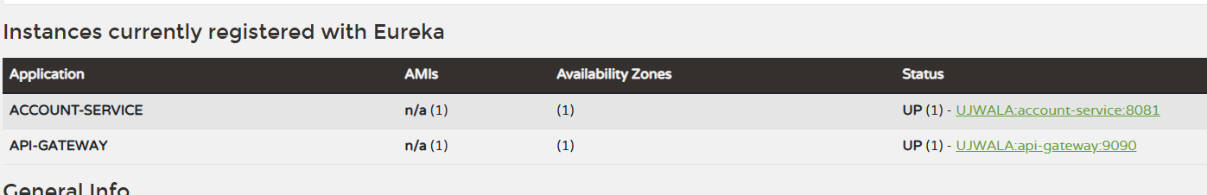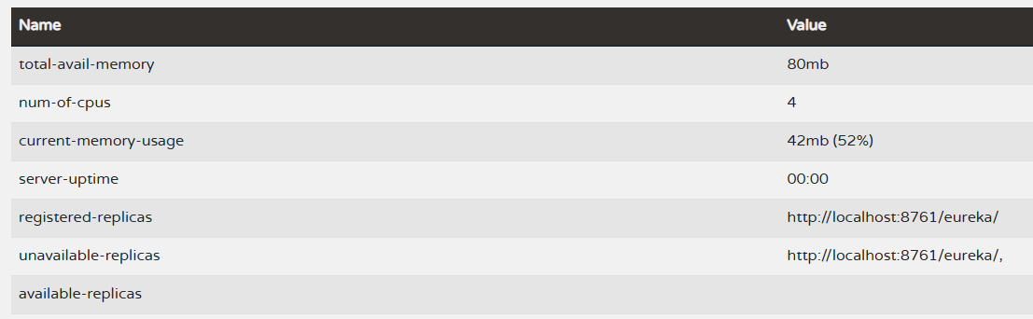

LOAN http://localhost:8761
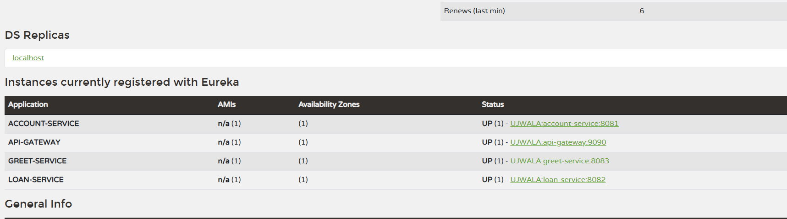

Greet-service
http://localhost:8083/greet
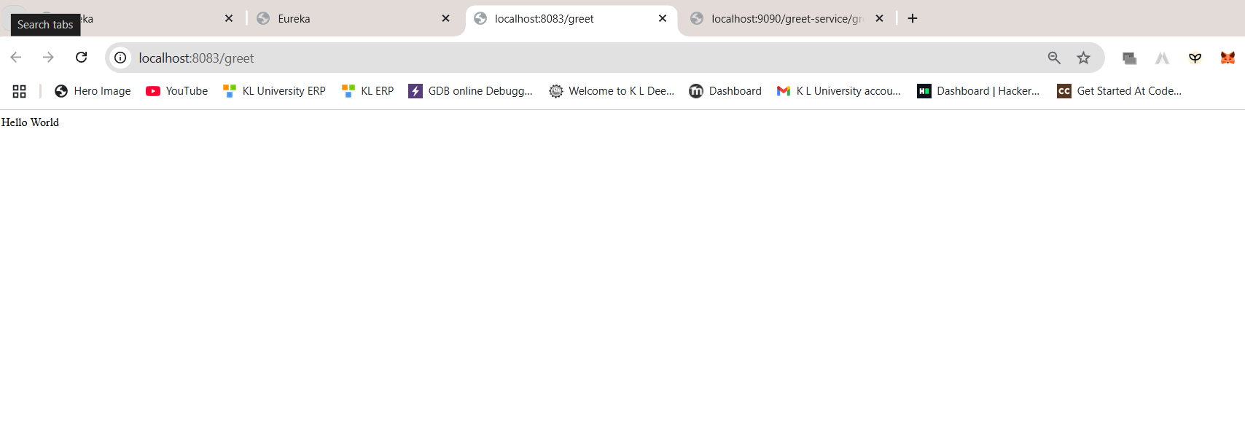

API GATE WAY
http://localhost:9090/greet-service/greet
